Formal Lab Report- Unknown “B”
Laura Kate Tharp
Tuesday, November 28, 2023
CHEM 2081-003
GTA: Dominic Fico

Introduction
Throughout this lab, we have done several experiments where it is essential to know the identity of the product that was created. Although there are many methods of learning to determine accuracy of product that have been taught in this lab, methods such as Nuclear Magnetic Resonance, Gas Chromatography/Mass Spectroscopy, and Infrared Spectroscopy are much more accurate and precise, thus it is essential that we learn how to use these methods and determine the identify of a product based on their results.
Nuclear Magnetic Resonance (NMR)
Nuclear Magnetic Resonance, or NMR, is a method for identifying the structure of a chemical compound, and it involves studying the interaction between electromagnetic radiation and the nuclei of atoms. NMR can study a variety of different nuclei, including Hydrogen, Carbon, Nitrogen, Fluoride, and Phosphorus, and is used most often by organic chemists. Any nucleus with an odd number of protons or neutrons possesses nuclear spin, which is a quantum mechanical property than can be probed by an NMR spectrometer. The spinning proton creates a magnetic field called a magnetic moment, which interacts with opposing electrons to create a diamagnetism, which allows protons to absorb different frequencies of rf radiation, helping us to identify them. Protons that are surrounded by more electron density are shielded by the electrons, meaning they will absorb less, while protons with more electron density are unshielded, and will absorb more radiation. This allows NMR spectroscopy to probe different electronic environments of hydrogens in a molecule to determine their identify and compound. To read a Nuclear Magnetic Resonance Spectra, four types of information are extracted, and all are important for determining a compound: number of different types of protons, integration, chemical shift, and spin-spin coupling. The first step is to examine the number of different types of protons, which you read from right to left and count the groups of signals shown. The next step is to count the individual protons, or the integration of the compound, in which the height of each set of steps corresponds to the relative signal intensity, allowing you to identify the number of protons displayed. Then you can use those protons to determine any primary, secondary, or tertiary hydrogens in the structure. Additionally, the location of the protons on the graph can be important when determining the chemical shift, which can help to identify different molecules structures, making it one of the most important elements in NMR spectroscopy. The final type of information is spin-spin coupling, or splitting the signal of one nucleus into the signals of many nuclei that might be coupled. These four elements can help you to identify the compound and structure of an unknown product.
Gas Chromatography/Mass Spectroscopy (GC/MS)
Gas Chromatography/Mass Spectroscopy (GC/MS) is a hybrid of two different methods which have been combined to make a more effective method of identifying a compound. In these, small samples of a stream from a gas chromatograph are directed into a mass spectrometer. This causes the molecules in the sample to become ionized by the electron impact and the resulting ions are accelerated and passed through a mass analyzer. This results in a mass spectrum for every compound from the gas chromatograph. This method is very efficient for analyzing compounds because it provides three different types of information: the number of components in the mixture, a rough measure of their amounts, and the possible identities of their compounds. The GC/MS is read by examining the height of the peaks and their relative location to determine their identity. It is typically presented in graphical form as a histogram of ion intensity, and the peaks show the compound of the product and help to identify it. The first area to look at in a GC/MS histogram is the molecular ion region. If the molecular ion does not completely fragment from the Gas Chromatography before being detected, its value will provide the molecular weight of the compound, which can be very beneficial when determining the unknown. From there you can analyze the peaks presented to reveal the unknown’s identity.
Infrared Spectroscopy (FMIR)
Infrared Spectroscopy (FMIR) is another vital method of identifying unknown compounds, in with infrared energy is passed through a sample of an organic compound and absorption bands are observed. It provides a very fast and effective method for identifying the prescience or absence of functional groups. In this FMIR spectra, the mid-infrared range is the most important to analyze, because that is where typical organic products appear. The positions of the Infrared absorption bands correspond to certain types of chemical bonds, which can provide information about function groups within the compound. When reading a FMIR spectra, the energy measured as frequency or wavelength is located on the horizontal axis, and the intensity of absorption is on the vertical axis. As the radiation passes through a compound, certain vibrations can be observed: stretching, bending, and scissoring. The vibrational patterns of the molecules can help us to identify the absorption bands and the identity of the compound. When reading the FMIR spectra, one looks at the shape and absorption levels of the molecules compared to the frequency to observe patterns and identifying functional groups. Three are three main regions of the FMIR spectra: functional group region. Fingerprint region, and aromatic region. The functional group region is the most important as it contains information about possible functional groups, which can lead to identifying the compound.

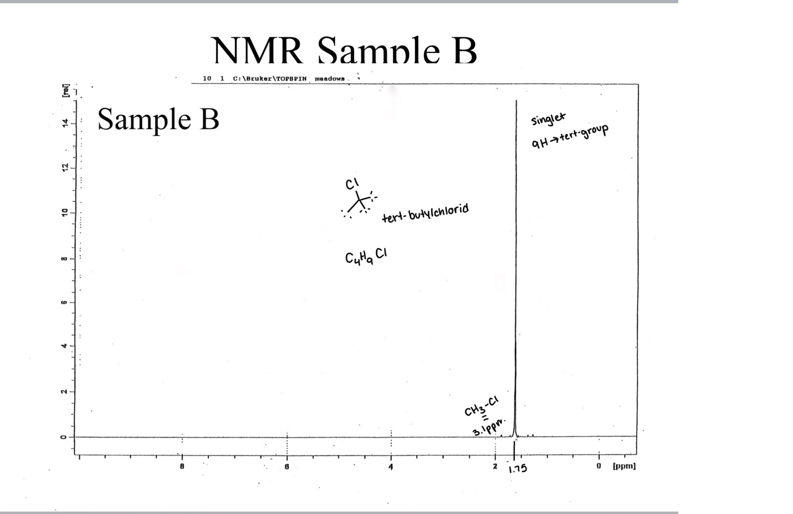
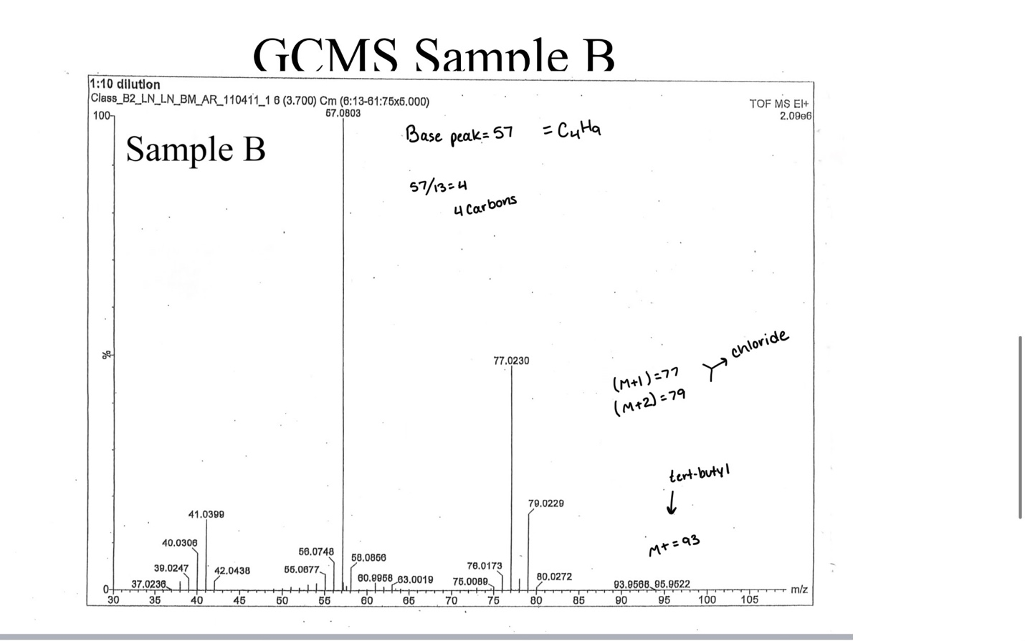
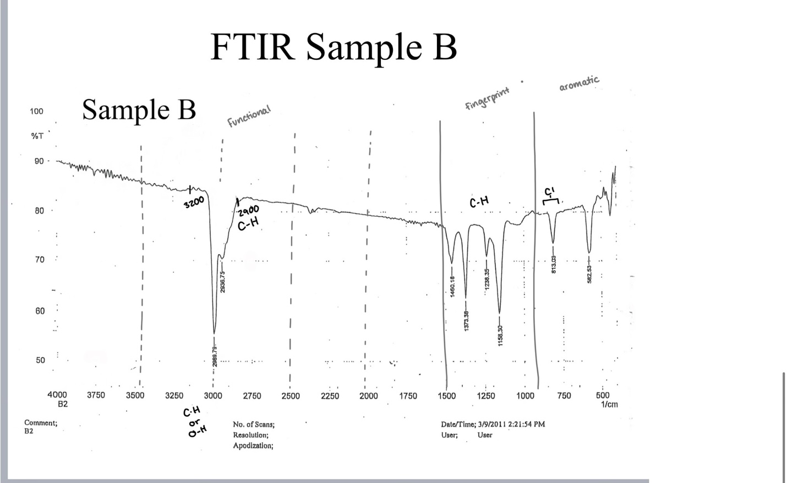

Conclusion
Based on the results of the NMR, GC/MS, and FMIR methods of identification, the product is concluded to be tert-butylchloride, or C4H9Cl. The functional groups identified were a tert-butyl group and a acyl halide group.

References
Keller L, Joseph K, and Miguel S, 2023 Fall. CHEM 2081 Organic Chemistry 2 Lab Manual [lab manual]. Auburn (Al): Auburn University

